Candidate Screening Tool

Admin Monitor Functional Process Flow

Table of Contents
Candidate Screening Tool 1
Admin Monitor Functional Process Flow 1
Table of Contents 2
Scope 3
Walk through of the Admin 3
Screen Flow 4
Figure 1 – Admin Monitor Screen Flow 4
Start Application 4
Main Screen 5
Connections Panel 5
File Menu 6
Server Menu 6
Actions Menu 6

Scope
This document is a Function Process Flow for the Admin Monitor portion of The Candidate Testing Application. The Admin Monitor will allow admins to monitor screening listeners and help diagnose problems with the listeners. Each screen will be defined along with the fields contained within each screen. This document will also provide the details about the navigation within the applet.

Walk through of the Admin
Here is an overview of the process that a candidate will experience when using the applet.

- Login using valid admin userid and password
- View admin listener connections
- View screening client applet connections
- View future sessions
- Disconnect an applet client
- Shutdown all the listeners
- Run garbage collection on the server VM
- Run system tests
- Ban an IP address

Screen Flow

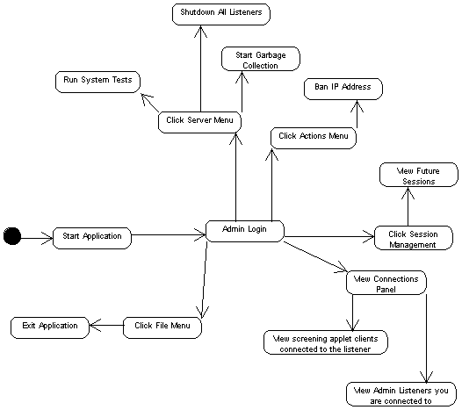Figure 1 – Admin Monitor Screen Flow

Start Application
When the application is first started, a dialog box will prompt the admin for a valid admin username and password. The admin will have to enter a username and password before using the rest of the application. This authentication must take place at application startup, and each time the application is reconnected to the admin listener (after network disconnects, for example).
This screen consists of the following fields:

Field Name | Field Type | Description
User ID | Entry field | A valid admin ID
Password | Entry field | The password
Ok | Push button | Successful login takes user to the Main Screen

Main Screen
Once logged in, the admin will be taken to the Main Screen. This screen is broken down into two sub-screens using a tabbed view. The tabs are: Connections, and Sessions. The main screen consists of the following fields.

Field Name | Field Type | Description
Connections | Tabbed button | Takes admin to Connections screen
Session Management | Menu Item | Brings up the Session Management Menu
File | Menu Item | Brings up the File Menu
Server | Menu Item | Brings up the Server Menu
Actions | Menu Item | Brings up the Actions Menu
Help | Menu Item | Brings up the Help Menu

Connections Panel
This panel is split into two sections, the admin listener connections, and the applet client connections. The admin listener connections part shows a list of admin listeners that this monitor is connected to.

Field Name | Field Type | Description
ServerID | Table Column | ID of admin listener server
Status | Table Column | Shows whether the admin listener is connected
IP Address | Table Column | IP Address of the admin listener
Port | Table Column | Port of the admin listener

The applet client connections part shows a list of the applet clients that are connected to the admin listeners.

Field Name | Field Type | Description
ServerID | Table Column | ID of admin listener server
ID | Table Column | ID of the applet client connection
IP Address | Table Column | IP Address of the applet client connection
1 sec | Table Column | # bytes sent in the last second
5 sec | Table Column | # bytes sent in the last 5 seconds
10 sec | Table Column | # bytes sent in the last 10 seconds
Total | Table Column | Total number of bytes sent

Session Management Menu
This is the Session Management Menu

Field Name | Field Type | Description
View Sessions | Menu Item | Brings up a frame showing the future sessions in the system

File Menu
This is the File Menu.

Field Name | Field Type | Navigation
Exit | MenuItem | Exits the application

Server Menu
This is the Server Menu.

Field Name | Field Type | Navigation
Run System Tests | MenuItem | Runs system tests on the server
Disconnect Applet Client | MenuItem | Allows the admin to disconnect a client connection by ServerID and ConnectionID
Shutdown All Listeners | MenuItem | Shuts down all the listeners
Start Garbage Collection | MenuItem | Starts garbage collection on the server

Actions Menu
This is the Actions menu.

Field Name | Field Type | Navigation
Ban IP Address | MenuItem | Allows the admin to ban an IP address.

